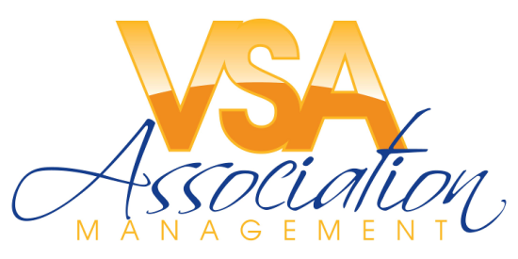

Date: April 23, 2021

To: Valued Homeowners at TIMBERLAKE COMMUNITY ASSOCIATION, INC.
From: VSA Association Management, LLC

Re: Introduction of Community Management Services-Welcome!

The team of professionals at VSA Association Management, LLC has been retained to provide management responsibilities for your community, effective April 21, 2021. We are excited about the opportunity that your Board of Directors has offered us.

New Contact Information: vsaassist@vsaamgmt.com or 757-821-8425
Website Inquiries: www.vsaamgmt.com Community Emergency Hotline: 757-425-2200

Please mail your association payments c/o VSA Association Management to:

P.O. Box 9295 Virginia Beach, VA 23450, payable to: TIMBERLAKE COMMUNITY ASSOCIATION, INC.

EFFECTIVE IMMEDIATELY: To ensure your payments are received in a timely manner, those on monthly ACH with the prior firm, you will need to cancel and set up new recurring for FREE through your VSAAM TOPS Owner Portal Page (information and instructions included). Those with payments sent automatically from your bank, please update with the address provided above. Please complete and return the Owner Resident Form attached as soon as possible to vsaassist@vsaamgmt.com!
- Occasional onsite visits to identify any community-related maintenance concerns and to ensure compliance with your Governing Instruments.
- Communicate with Owners, Residents, Tenants, Vendors, and the Board of Directors for concerns relative to the business of the Association and common areas.
- Manage and monitor vendors with existing contracts with the Association, common area maintenance issues, and building/common area repairs, as approved by your Board of Directors.
- Track member payments, inquiries, correspondence and suggestions.
- Provide monthly financial statements to the Association.
- Communicate items of community interest via electronic transmission or other means as approved by the Board of Directors.
- Attend Board of Directors meetings as needed.
- Coordinate the Annual Meetings of the Membership.
- Solicit bids from third-party vendors when directed by the Board of Directors.
We recognize that your home may be the biggest and most important investment. We are committed to addressing concerns regarding your community in a timely manner. We will track and monitor all forms of communication and respond to all telephone calls and emails before the same time the following business day (except in the case of an emergency). If you have any common area issues that are outstanding or of concern, please contact us so that we may follow-up and ensure that all items are addressed accordingly. Thank you again for the opportunity to serve each of you, we are looking forward to working with you.
If you have any questions, please contact us vsaassist@vsaamgmt.com or 757-821-8425.
Beverly O’Quinn, CMCA, AMS
VSA Association Management, LLC

